JOY Dogs 2018

The highlight must be the arrival of Orion from Barnaul in Siberia
Thanks must first go to the breeder Valeriya, for being willing to send me a puppy and for looking after him so well. Thanks too, to Jenny Shone for her help in getting Orion here and Melanie (Animal Travel services) and Valeria (the travel agent in Moscow). Thanks too to Petra du Toit and Tanya for assisting with Orion’s introduction to the JOY Dogs.

The first 4 collages are from when Orion was still in Barnaul

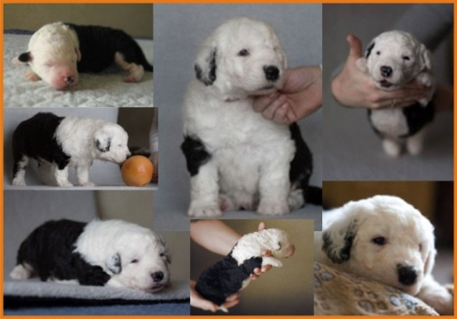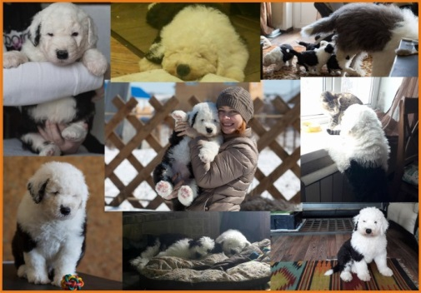

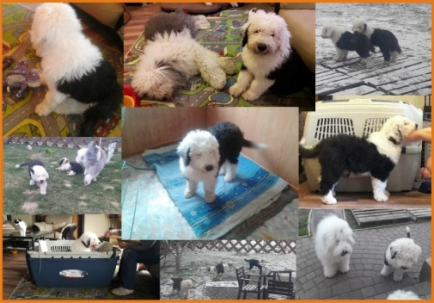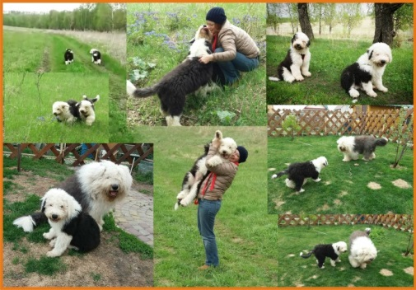

and now in Johannesburg

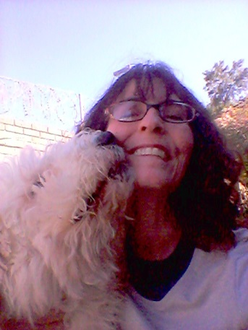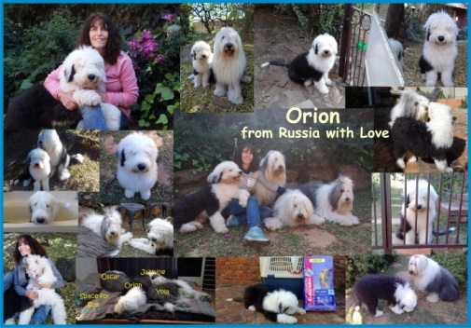

Orion was so happy to get to his new home after the 3 days of travel and the week of quarantine, he wagged his tail so much and damaged the end (it’s called happy tail syndrome) and it took about 5 weeks to heal and stop bleeding. It was very traumatic for me and I guess for him too.
He has settled in very well and gets on well with the other dogs and is already working as a JOY Dog and also does promotions for Dulux.

I have sadly had to retire Oscar as he has struggled this year with coughing and back problems but does still go out and on short walks.
Here are some of the places the JOY Dogs visited.
2 aged homes
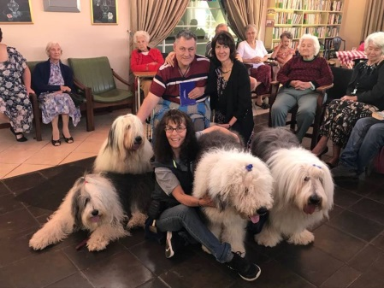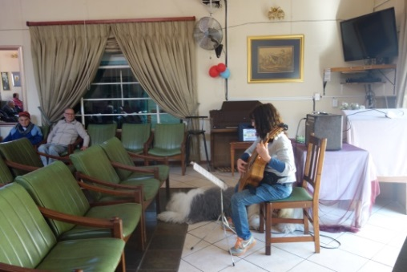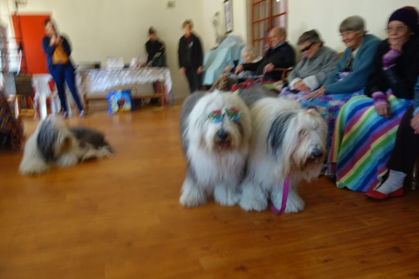
Moreglans 3 visits Randvaal

2 primary schools
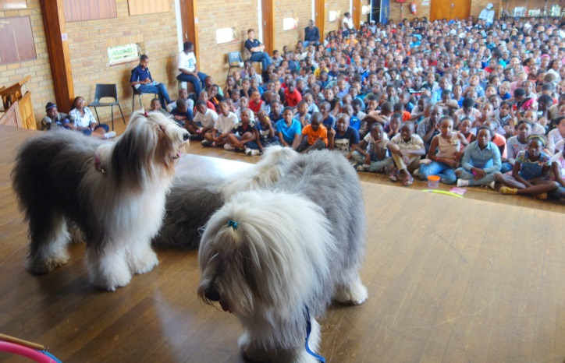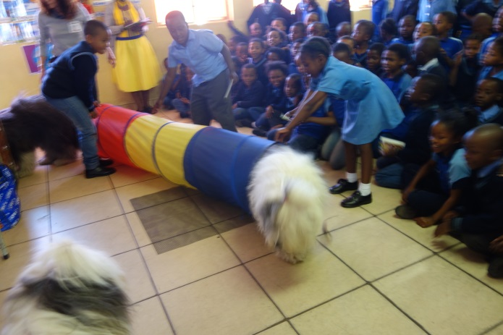
Park Senior Asteri

2 corporate wellness visit
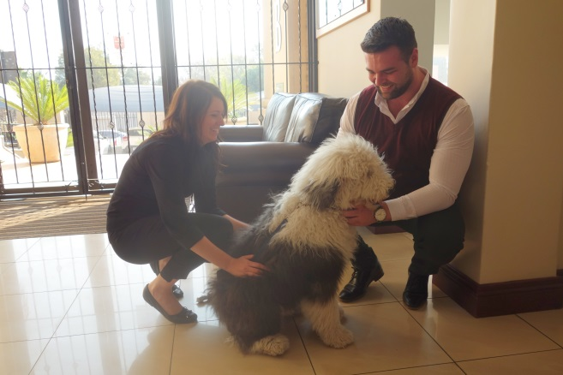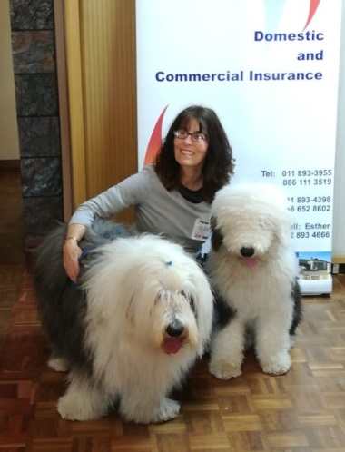
HLB Barnett Choice brokers

2 preschools

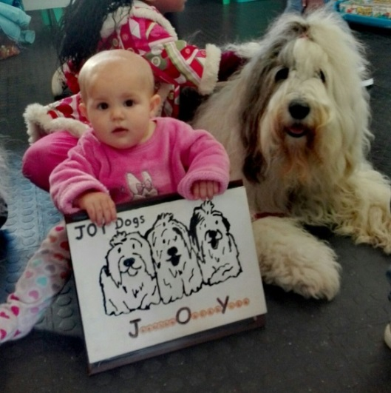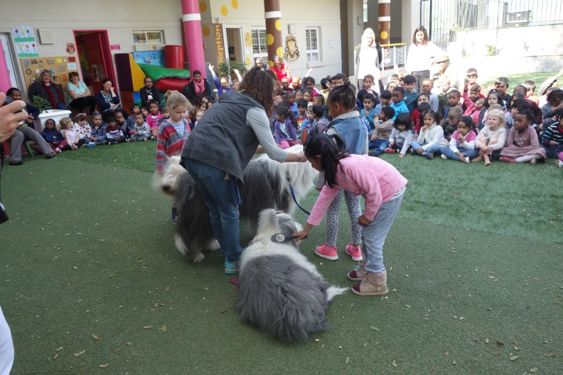
Clever Kids Montrose
2 Senior groups - and a special appearance at Jenny Shone’s show and fundraiser at Second Innings.

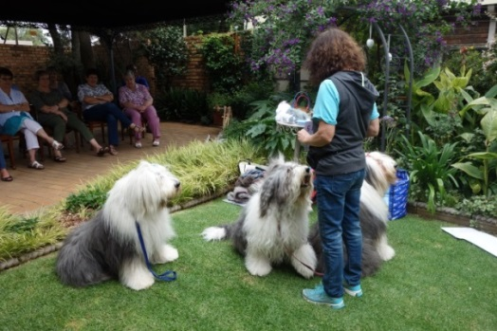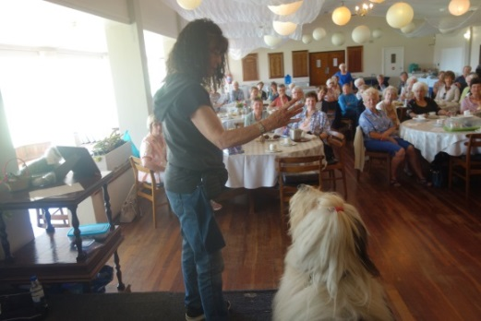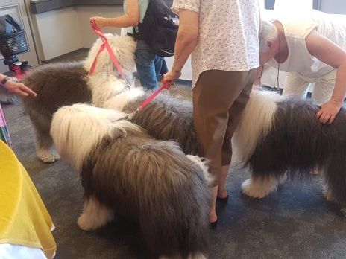
Frieda’s Group Ladies Interest League Second Innings

2 church groups

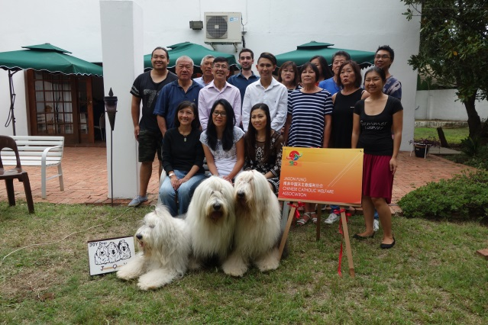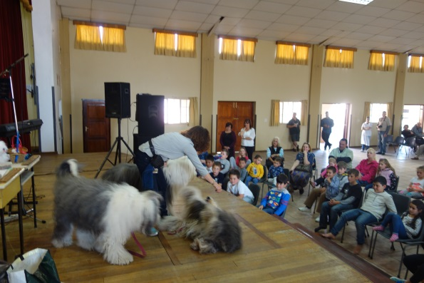
Chinese Catholic Welfare Lady Fatima - Benoni

Corporate show

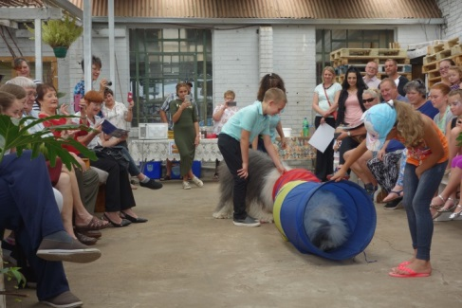
Out of Africa Pet supplies

4 community events
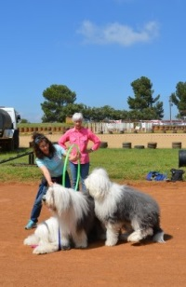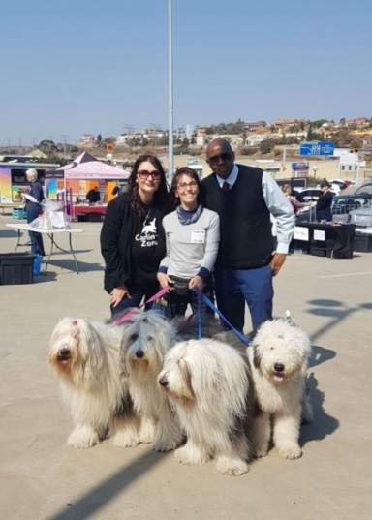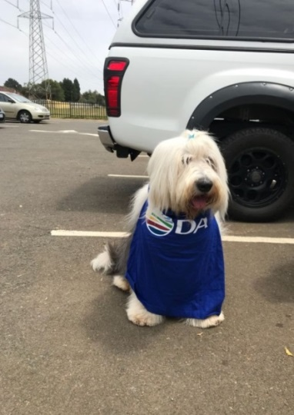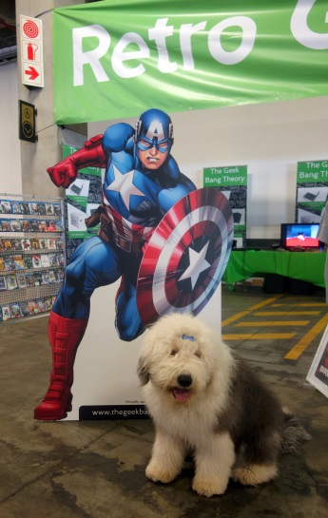

Walkerville Show Pet Expo at the Glen Voting station Comicex

24 Dulux promotions
6 country trips for Dulux : Brits, Ermelo, Welkom, Senekal, Nelspruit (we stayed over) and Potchefstroom
Oscar’s advert from last year was sold to Botswana

Oscar’s new Dulux Commercial
Win a Volvo competition – Oscar had to pose in front of a fan in the studio and the picture was then edited.



We had several articles: tame TIMES (2) and one in Krugersdorp News, as well as the North Coast Courier (2)and Comaro Chronicle (2)

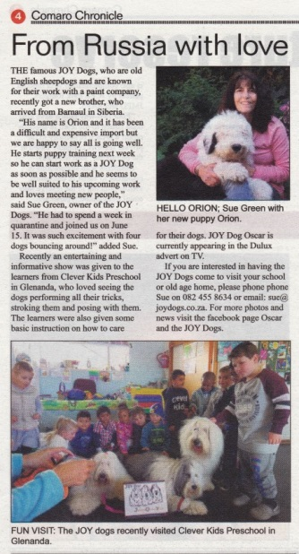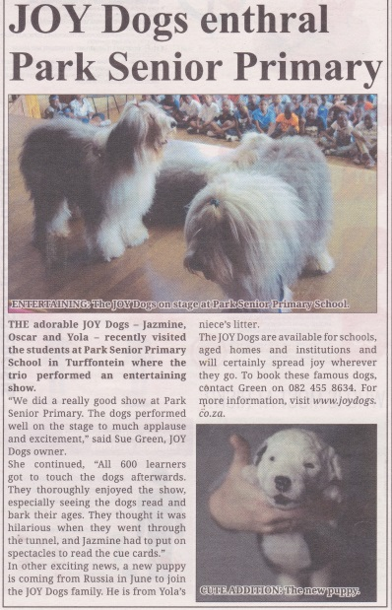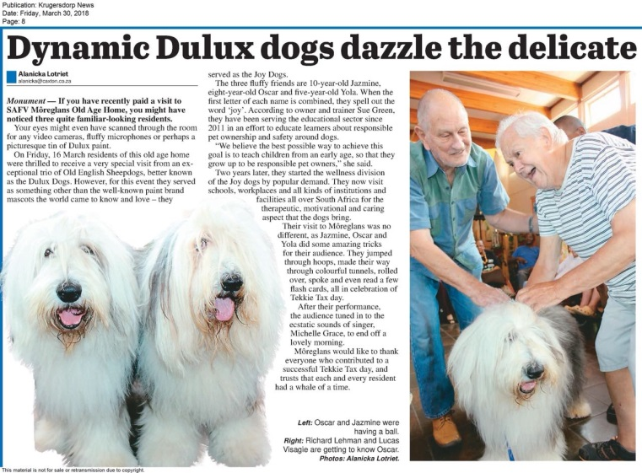

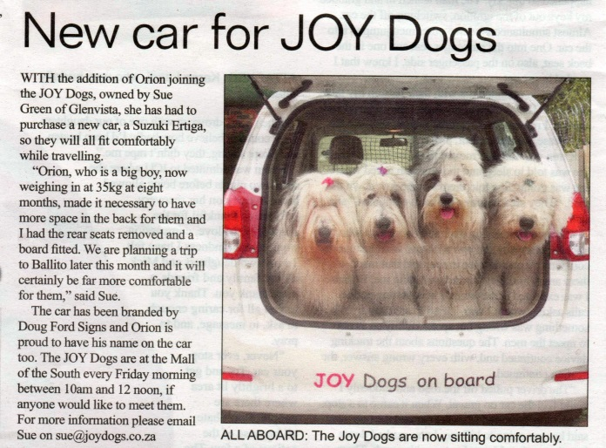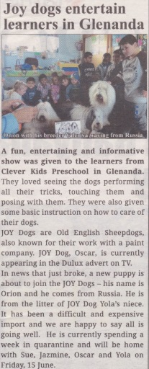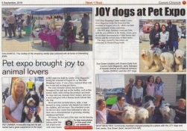
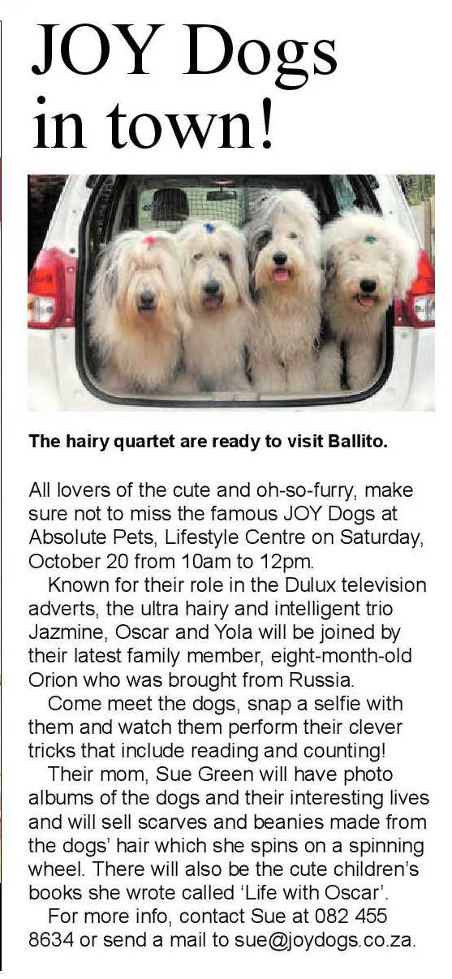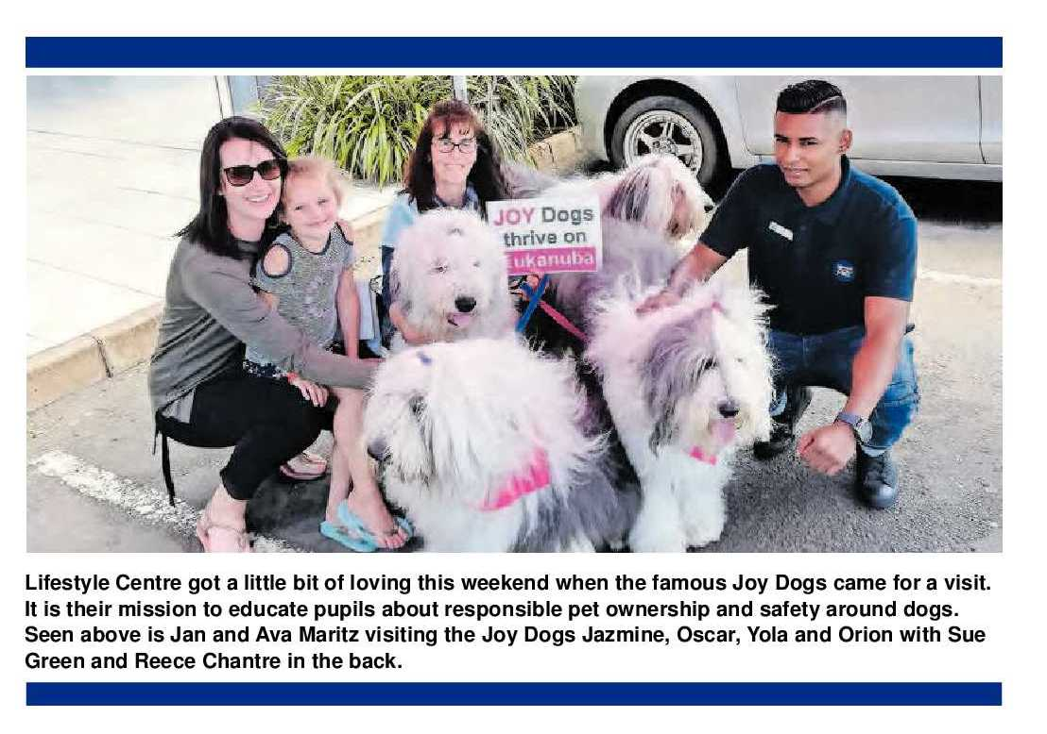

We visited the Glen and Mall of the South. Sadly our visits to the Glen have stopped as someone complained about the dogs but we still go to Mall of the South.

We continued our friendship with Caring Friends therapy dogs from Vanderbijlpark. Orion achieved Silver and Bronze CGC (Canine Good Citizen) and Yola got Gold.

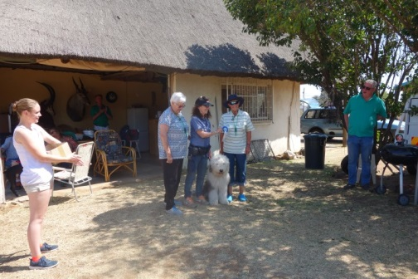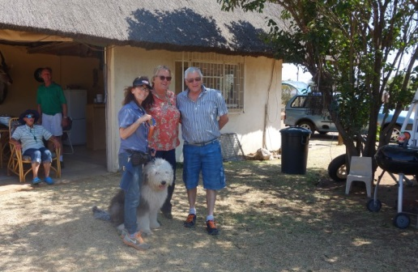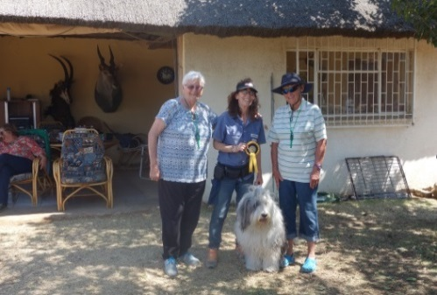

Orion graduated puppy school

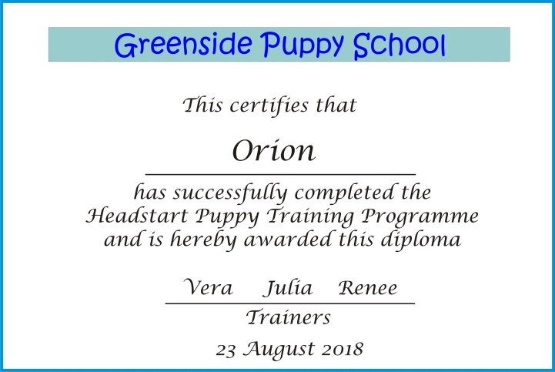

We did 5 promos with Eukanuba

Pets Eats and Treats in Honeydew. VIP Pets in Little Falls, Fluffs and Tufts in Magaliesig and 2 training evenings and Absolute Pets in Ballito. The dogs are now accredited ambassadors for Eukanuba.

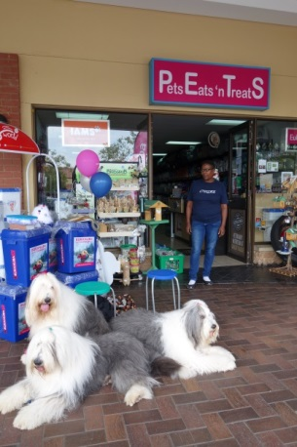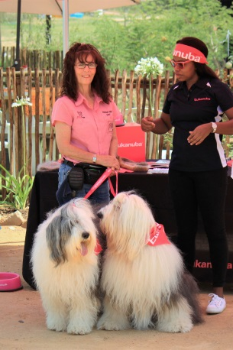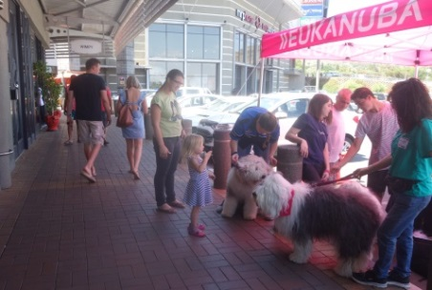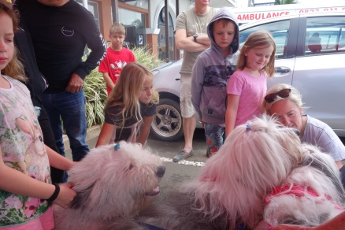

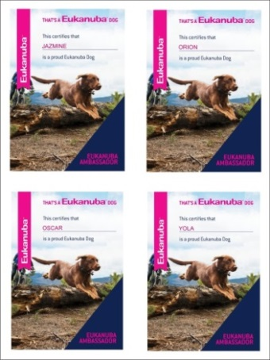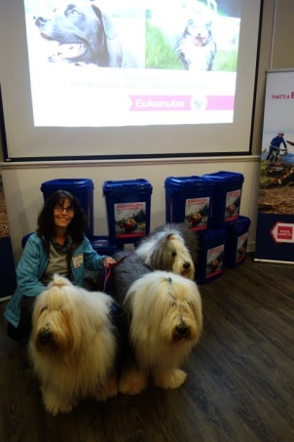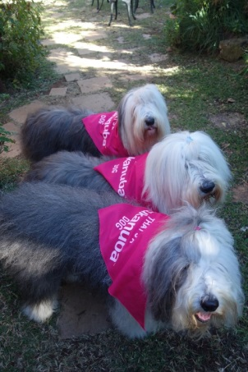

A skype interview with Daniel a scholar from Germany and he wrote this poem

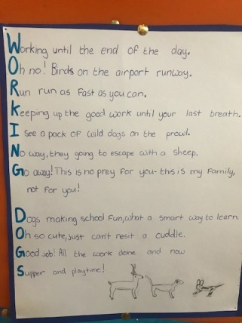

Birthday parties – a four year old and an eleven year old – both successful

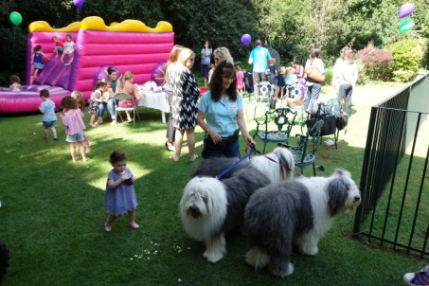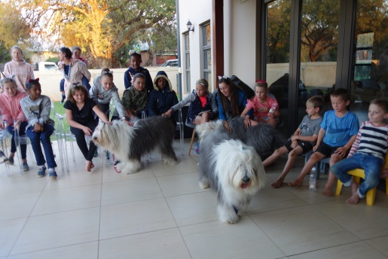

A new Suzuki Ertiga was purchased as the Honda Jazz was getting a bit small

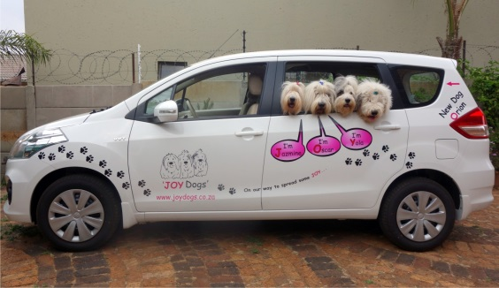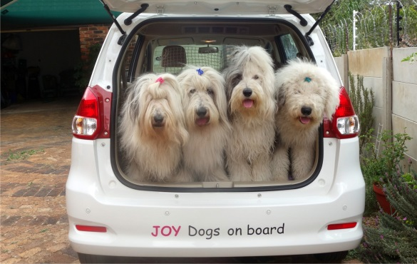

Estelle Hulsman and Jacquie Biart continued to work with the team as well as Megan van Maltitz from Riverclub Veterinary Clinic. We have new additions Nadia from Potchefstroom and Gloria and Paula from JHB south. Kathie from the West rand also assisted with some promos. Some of you assisted with puppy sitting Orion when I had to work and I’m so grateful to be able to rely on my friends.

We have maintained our previous sponsors and are very grateful to all. I continue to pop into those sponsors that I can to spread some JOY with the dogs. We welcome a new sponsor – Ascendis

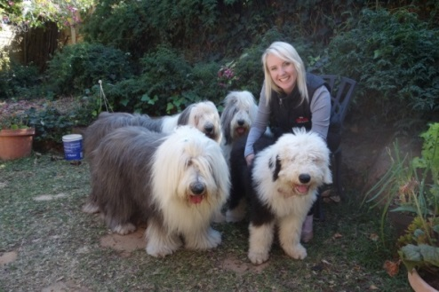

We visited Mareli in vdbijl who imported Hannah from Italy – we are hoping Orion can breed with Hannah when she is ready in another year or two.

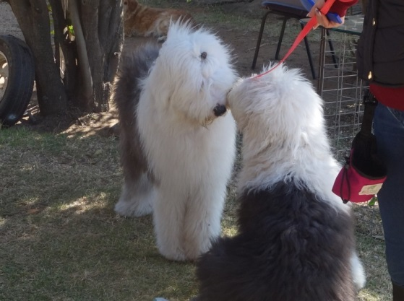

Hairclips : My friend in Switzerland Vreni sent us some lovely hairclips – love the name Fortuna’s JOY

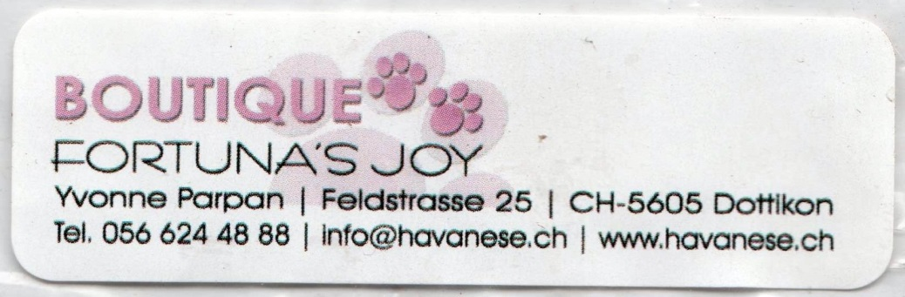

I continue to spin the dog hair and the new JOY Ashford portable spinning wheel goes along to shows. I made a special scarf from Orion’s puppy hair and sent it to Valeriya the breeder in Siberia. I also cut my own hair shorter and spun some of it to see if it was possible.

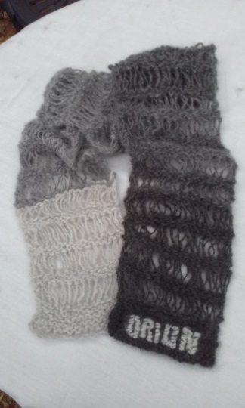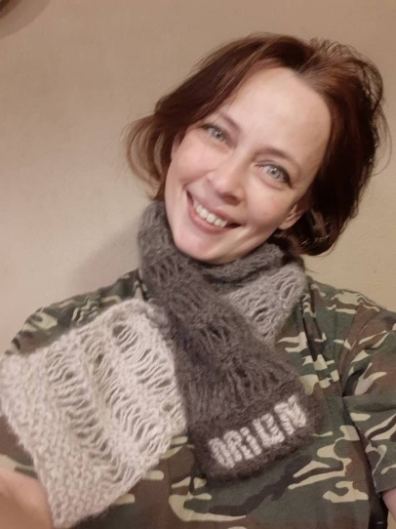

No radio interviews this year but 1 magazine mention - Canine Zone

Canine Zone Magazine
18. EVENTS
The Canine Zone Pet Expo @ The
Glen Shopping Centre

The dogs went on a working holiday to Ballito and we got some wonderful beach photos. It was very windy!
Thanks to Paws for Thought for our sponsored accommodation – we always enjoy our stay there.

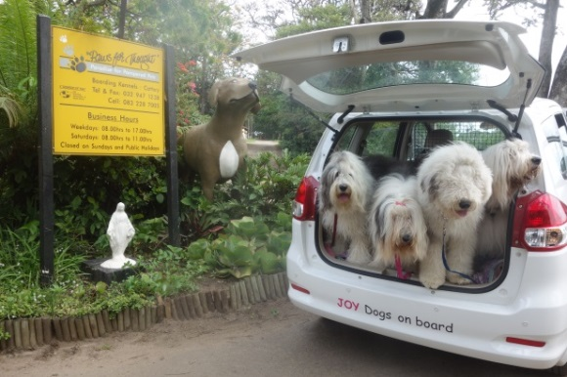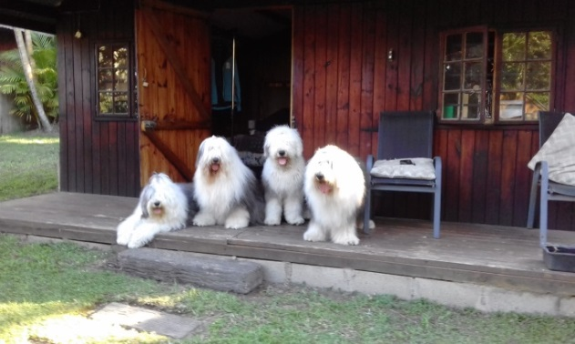

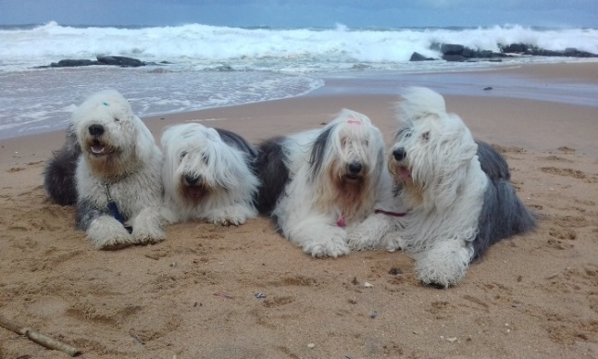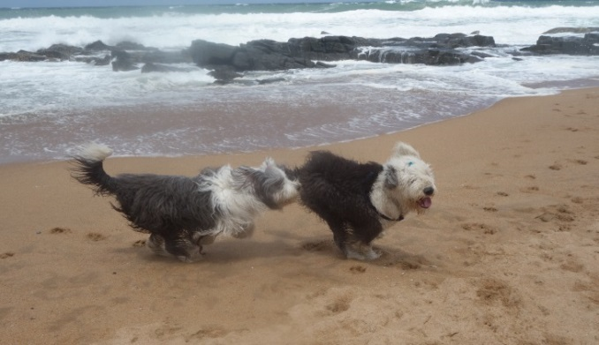

I sent out approximately 50 updates.

Music –I did 6 guitar gigs

The JOY Dogs are listed with Gigster, Pathfinder and Google My business.
The website is working well and has been maintained. www.joydogs.co.za

Jazmine is now 11, Oscar 9 and Yola 6 years old. Orion was born on 7 February so is not yet 1.

My favourite photo of Orion
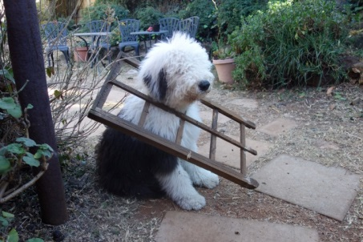

We are happy with what we achieved this year and look forward to 2019.

Best wishes for 2019, may you all be healthy, happy, wealthy and wise.

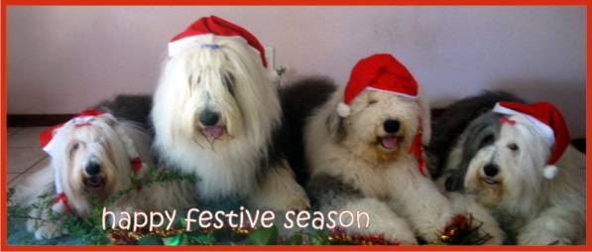

Sue, Jazmine, Oscar, Orion and Yola

